Task 1: - List 3 key differences between Ethernet cables and fiber optic cables, and give one real-world example where each type would be used (for example, home WiFi router, data center, college campus backbone).
3 Key Differences Between Ethernet Cables and Fiber-Optic Cables
No. | Ethernet Cable (Copper) | Fiber-Optic Cable
1. Transmission Medium | Transmits data using electrical signals through copper wires. | Transmits data using light signals through optical fibers.
2. Speed and Distance | Commonly supports 1 Gbps over distances up to 100 metres; higher speeds are possible with suitable cable categories and equipment. | Supports very high speeds over much longer distances, depending on the fiber type and equipment.
3. Interference | Can be affected by electromagnetic interference, depending on cable type and shielding. | Immune to electromagnetic interference.
Real-World Examples
- Ethernet cable: Connects a home Wi-Fi router to a desktop computer or gaming PC for a stable wired connection.
- Fiber-optic cable: Connects buildings across a college campus or links servers in a data center for high-speed data transmission.
Conclusion: Ethernet cables are cost-effective and convenient for short-distance connections, while fiber-optic cables are ideal for high-speed, long-distance networking.

Task 2: - Draw and label a diagram showing the internal wiring of a straight-through Ethernet cable (use T568B wiring standard), indicating the color of each wire and its pin number.
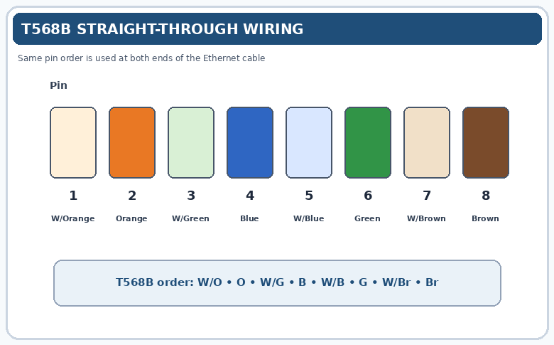

Task 3: - Watch a YouTube video demonstrating how to use an RJ45 crimper, then write a step-by-step guide (in your own words) on how to attach an RJ45 connector to a CAT6 cable.
Practical: How to Attach an RJ45 Connector to a CAT6 Cable
YouTube tutorial
Watch this step-by-step demonstration before performing the practical:
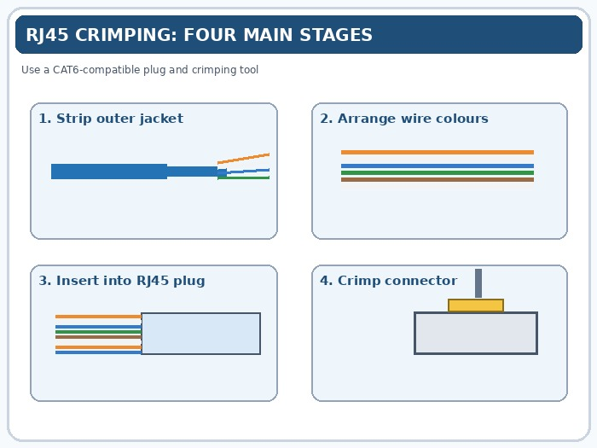
How to CRIMP CAT6 RJ45 – Tutorial (BEST Method)
By Low Voltage Nation
Watch on YouTube

YouTube
Materials required
- CAT6 Ethernet cable
- RJ45 connectors compatible with CAT6 cable
- RJ45 crimping tool
- Cable stripper or wire cutter
- Ethernet cable tester
Step-by-step procedure
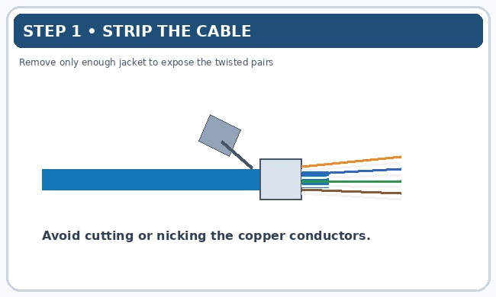
Step 1: Cut and strip the cable
Cut the CAT6 cable to the required length. Use the stripper to remove approximately 2–3 cm of the outer jacket without damaging the internal wires.
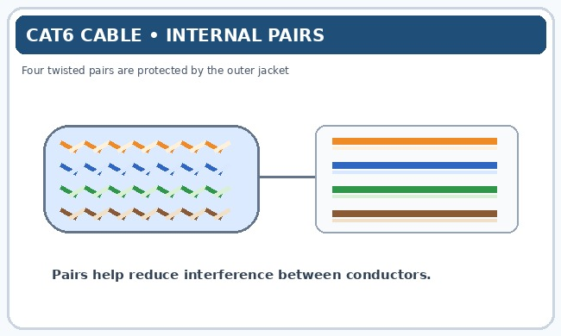
Step 2: Separate the wire pairs
Separate the four twisted pairs and carefully remove the internal plastic separator if the cable has one. Untwist only as much as needed to arrange the wires.
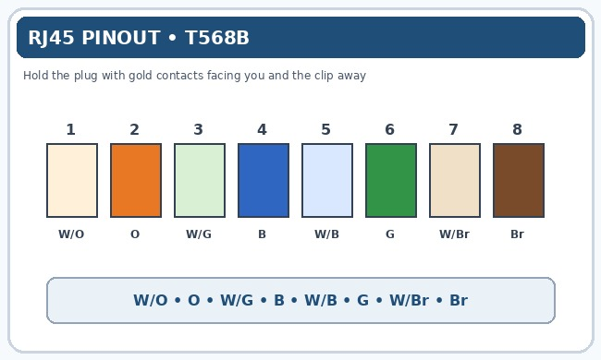
Step 3: Arrange the wires in T568B order
Hold the wires flat and arrange them from left to right in this sequence:
- White/Orange
- Orange
- White/Green
- Blue
- White/Blue
- Green
- White/Brown
- Brown
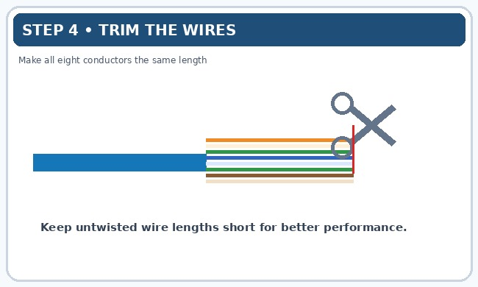
Step 4: Trim the wires evenly
Straighten the conductors and cut their ends evenly so they fit into the RJ45 connector. Keep the exposed untwisted sections as short as practical.
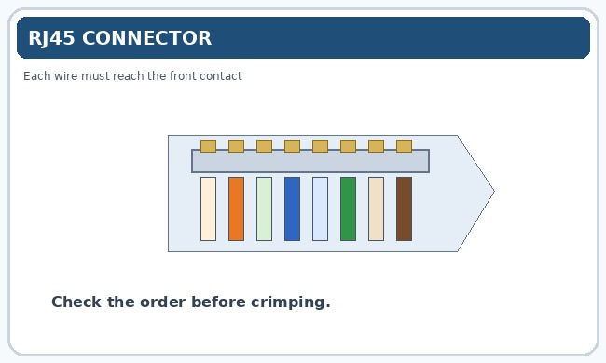
Step 5: Insert the wires into the RJ45 connector
Slide all eight wires into their individual channels. Check that every wire reaches the front of the connector and that the cable's outer jacket extends inside the connector beneath the strain-relief tab.
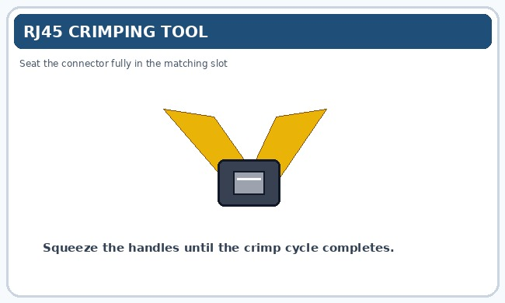
Step 6: Crimp the connector
Place the RJ45 plug into the correct slot of the crimping tool. Squeeze the handles firmly until the crimping mechanism completes its cycle. This presses the contacts into the conductors and secures the cable.
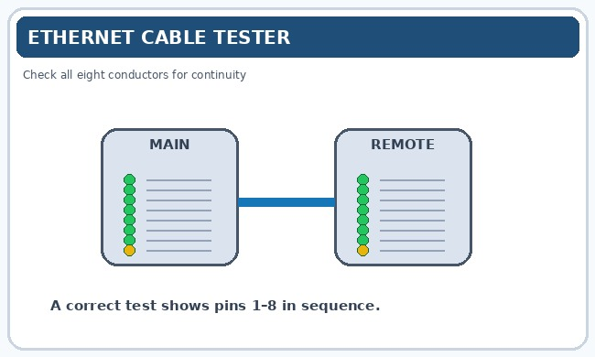
Step 7: Test the cable
Connect both ends to an Ethernet cable tester. Verify that pins 1 through 8 illuminate in the correct sequence and that there are no open circuits, shorts, or crossed wires.
T568B wiring reference
Pin | Wire colour
1 | White/Orange
2 | Orange
3 | White/Green
4 | Blue
5 | White/Blue
6 | Green
7 | White/Brown
8 | Brown
For a straight-through cable, use the same wiring standard, such as T568B, at both ends.

Task 4: - Imagine you are setting up a gaming café with 10 PCs for LAN gaming. Decide which cable type (Ethernet or fiber optics) and which tool (RJ45 crimper or fiber cleaver) you would use, and explain your choices in 3-4 sentences. Consider speed, distance, and budget for your answer.
- I would use Ethernet CAT6 cables to connect the 10 gaming PCs because they provide high speed, low latency, and reliable connectivity over typical café distances of up to 100 metres.
- Ethernet cables are also more affordable and easier to install than fiber-optic cables for short-distance connections.
- I would use an RJ45 crimper to attach RJ45 connectors to the CAT6 cables and ensure secure connections.
- A fiber cleaver is unnecessary because it is used to cut optical fibers, not copper Ethernet cables.

